**Database First Migration:**

1. Fork the project and clone it in VisualStudio
2. Delete files from DatabaseTask.Core and DatabaseTask.Core (including employee.cs)
3. Create Database named „PersonDatabase“ in MS SQL.
4. Create „Person“ table, which should look following: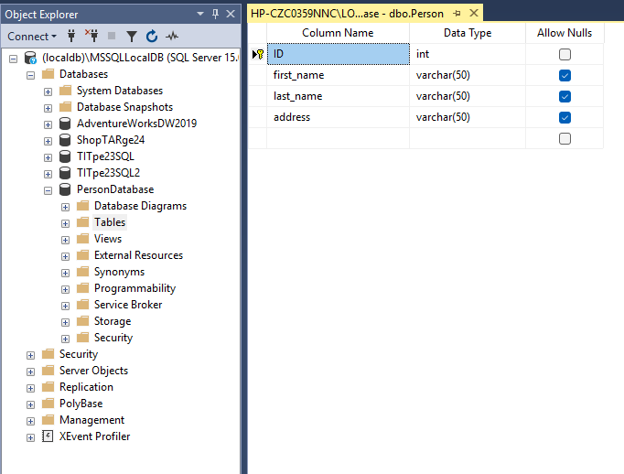
5. Add the following to appsettings.json :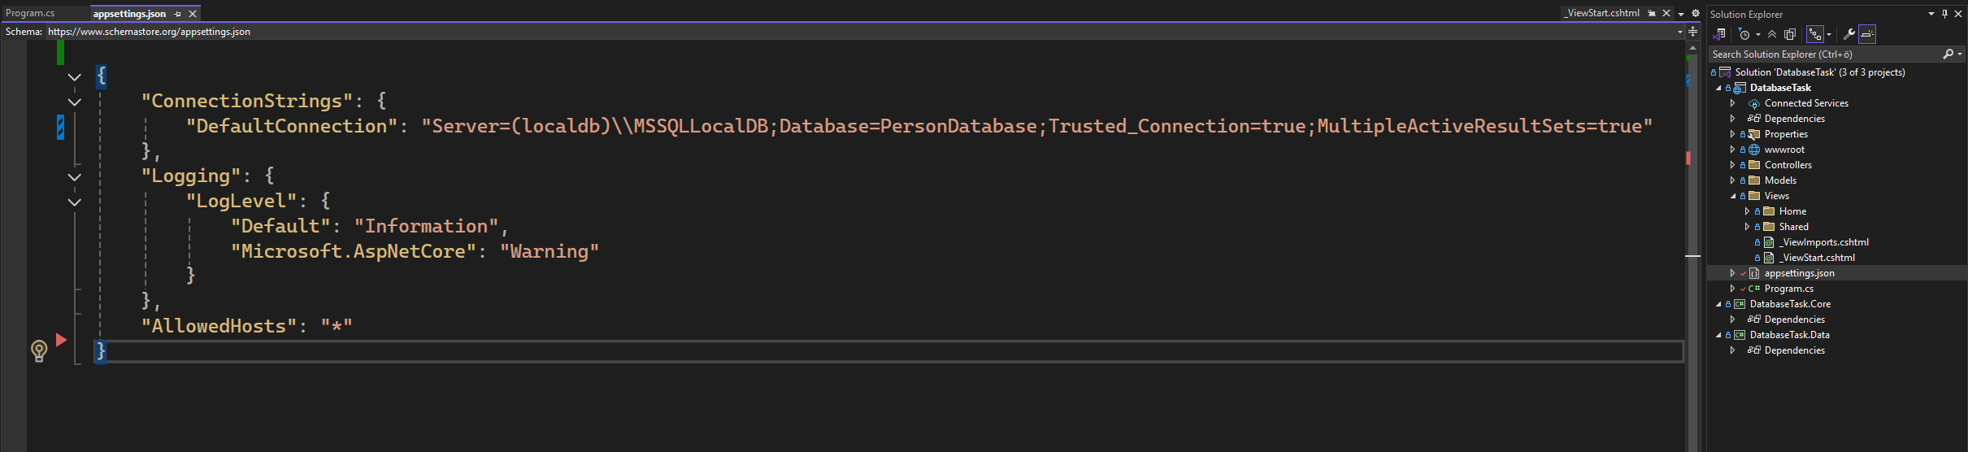
6. Comment out „<DatabaseTaskDbContext>“ and „using DatabaseTask.Data“ in Program.cs
7. Be sure to go into „Tools > Connect To Database“ and insert „(localdb)\MSSQLLocalDB“ into server name and select PersonDatabase  
   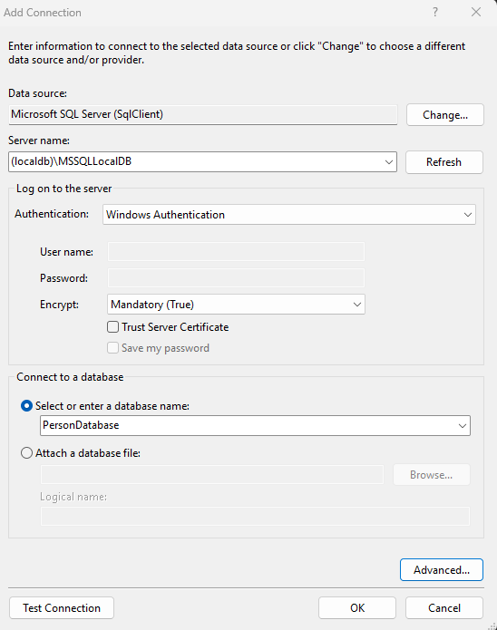
8. Go to „Package Manager Console“ with search function inside Visual Studio and throw following script:  
   Scaffold-DbContext "Name=ConnectionStrings:DefaultConnection" Microsoft.EntityFrameworkCore.SqlServer
9. Following should be a result:

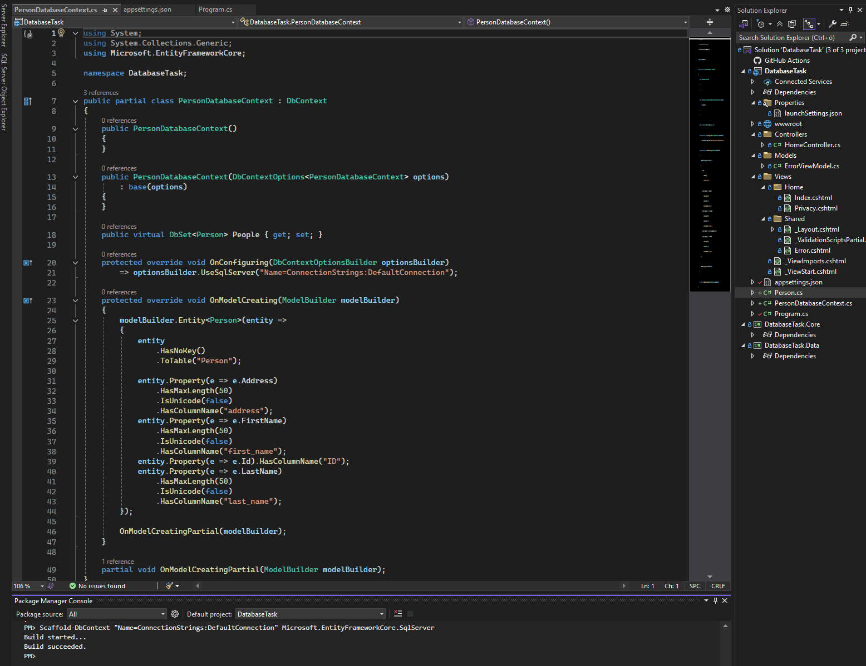

**Code First:**

1. Test
2. test